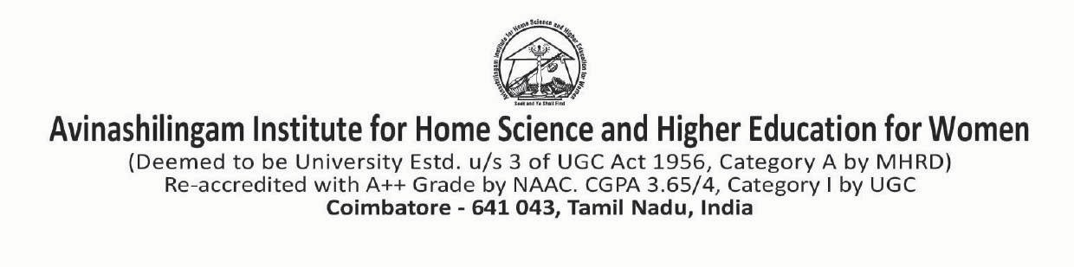
Application No.

Application for Self Supporting Programme
(Non-Teaching)

Advertisement No. Dated:

APPLICATION FOR THE POST OF _____________________________

Affix Passport
size colour
Photograph

- Name (in capitals) :

- Date of Birth :
Age as on the date of
Advertisement : Y……..….M…...….D…….……
- Place of birth :
Male | Female | Others
- Sex (Tick ) :
- Religion :
- Nationality : Indian / ……………………………
OC | SC | ST | OBC | EWS
- Community (Tick ) :
(Please enclose a copy of
the Community Certificate)

- Mother Tongue :
- District & State :
- Father’s/Spouse Name :
Occupation & Address (Strike out whichever is not applicable)

Address for Communication :
Residence: Office:
………………………………………………………………...... ..…………………………………………………………
……………………………………………………………………. ……………………………………………………………
…………………………………………………………………… ……………………………………………………………
Pin code: ………………………… Pin code: ……………………………………
Phone : …………………………Fax:……………
E-Mail :………………………………………………………… E-Mail :………………………………………
Mobile :………………………………………………………. Mobile: ……………………………………………

- Present position
Designation ……….…………………………..
Scale of Pay ……………………………………
Gross emoluments ……………………………………
- Educational Qualification : (Start from the latest)
(Please enclose xerox copies of the Certificates)
Sl.  No. | Examination Passed  (with main subject) | University / Institution | Year of Passing | % of  Marks /Grade | Class /Rank
1.
2.
3.
4.
5.

13 Experience :
Sl.  No. | Position held | Name of the Institution | Duration |  | Years of experience  Y M D
Sl.  No. | Position held | Name of the Institution | From | To | Years of experience  Y M D
1.
2.
3.
4.
5.

14. Languages Known :
Sl.  No. | Name of the Language | Read | Write | Speak
1. | Tamil
2. | English
3.
4.

15. Other Skills :
Sl.  No. | Type of Skill | Nature of Proficiency
1.
2.
3.
4.

16. Check list of enclosure : (Tick in the appropriate column)
Sl.  No. | Enclosure  (Attach attested relevant Xerox copies) | Attached | Not Attached
1. | Filled in application with enclosures
2. | Age Proof – HSC Mark Statement
3. | SSLC First Page / Mark Statement
4. | Community Certificate
5. | UG / PG Degree Certificates
17. Any other:

18. I hereby declare that the entries in this form are true to the best of my knowledge and belief.
If selected, I will abide by the rules and general service conditions of the University.

Place:
Date: Signature of Applicant

